 | 12.3.1 Editors - Geometry Nodes Editor - Sidebar - Node tab
Table of content
Node panel 1
Name 1
Label 1
Color Subpanel 1
Presets 1
Node color specials 2
Copy Color 2
Properties panel 2
Repeat panel 2
Active Item Index 2
Add Repeat Item 3
Remove Repeat item 3
Move Repeat Item up or down 3
Filter Options 3
Filter by name 3
Invert 3
Sort by Name 3
Reverse 3
Pull handler 3
Socket Type 3
Inspection Index 3

Node panel

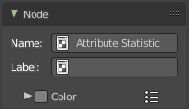
Name
The name of the selected node. Read only.
Despite being read only, this text can be edited. But be careful, it will not change the name in the header of the node. And it does not snap back to the original name of the node when you remove the custom text.

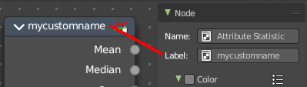
Label
Allows you to define a custom name for the selected node. This text does change the name in the header of the node.

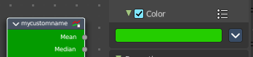
Color Subpanel
Define a custom color for the node. A click at the color field opens a color picker.

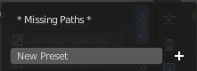
Presets
Add color presets.

Node color specials

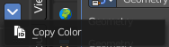
Copy Color
Copies the color. Which doesn't help you since you cannot paste it.

Properties panel

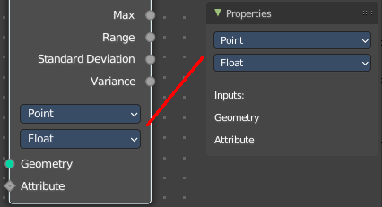
Lists the properties of the node in editable form. And the inputs in text form.

Repeat panel

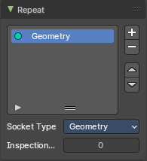
Repeat Zone node only. Repeat Zone settings.

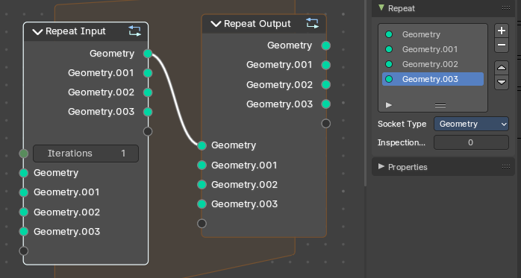
Active Item Index
List of active in- and output sockets.

Add Repeat Item
Adds a new socket item.

Remove Repeat item
Removes the selected socket item.

Move Repeat Item up or down
Moves up or down the selected socket item.

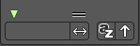
Filter Options
When you click at the arrow button down left then you can reveal the filter options.

Filter by name
Filter the content by name by typing in the name in the field.

Invert
Inverts the filtering by name.

Sort by Name
Sort alphabetically. A is at the top.

Reverse
Sort alphabetically in reverse order. A is at the end of the list.

Pull handler
Resize the list.

Socket Type
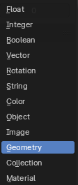
What socket type the currently selected socket is.

Inspection Index
Iteration index that is used by inspection features like the viewer node or socket inspection. This value specifies which iteration should be used by the inspection features.

